
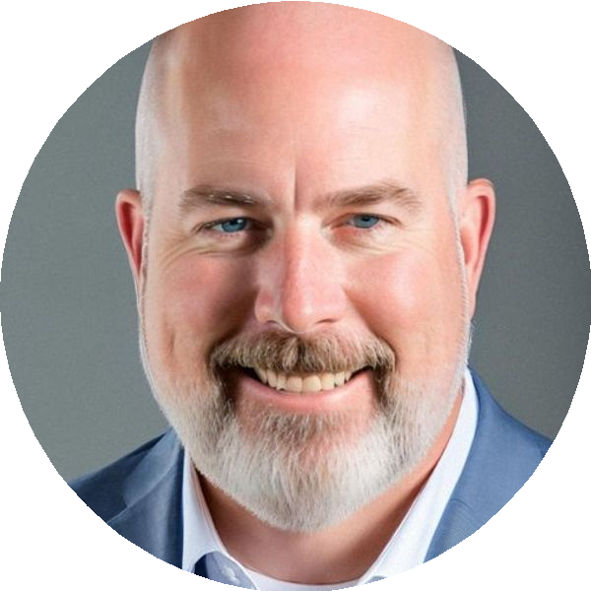

Bryant Lister

Vice President of Data Strategy, Trella Health
bryant@bryantlister.com 503-708-2126 Eugene, Oregon  linkedin.com/in/bryantlister bryantlister.com

Bryant Lister built his career at the intersection of healthcare complexity and data discipline. For over 25 years, he has operated in environments where data is not merely an asset but a regulated, protected, and strategically contested resource. His path has taken him from hands-on software delivery through some of the largest public-sector healthcare operations in the United States, and most recently into the high-growth, private-equity pressure of a $200M manufacturer scaling from regional player to national brand.

At the Oregon Health Authority, Bryant did not simply manage data. He built the governance infrastructure that allowed one of the nation's largest public health organizations to trust its own information. He developed ownership and stewardship frameworks, metadata standards, and lifecycle controls across Medicaid, managed care, behavioral health, and long-term services. When a major breach exposed sensitive healthcare information, he stepped in as Interim Chief Information Risk Officer and incident commander, coordinating legal, federal, law-enforcement, and executive stakeholders while leading NIST 800-53-aligned remediation that restored control maturity and public trust.
What distinguishes Bryant is his ability to translate governance into velocity. At L.A.B. Golf, recruited after private-equity investment, he built the company's first enterprise data strategy and responsible AI governance framework from nothing. He established decision rights, portfolio governance, and cross-functional accountability across ERP, CRM, e-commerce, and analytics platforms. He did this not by slowing the business down, but by giving it the controls required to scale without breaking.

For Trella Health, Bryant offers a rare combination: deep healthcare data governance rooted in HIPAA, PHI, and claims-clinical-operational integration, paired with recent experience building AI oversight and data strategy in a rapid-growth, investor-backed environment. He understands that post-acute care data fragmentation is not a technical problem alone. It is a trust problem. And trust is built through governance that is visible, accountable, and aligned to patient outcomes.
He holds a Doctor of Chiropractic from University of Western States, a Bachelor of Science in Biochemistry from UC Riverside, and maintains active certifications as a CISSP, CCSP, PMP, and CDMP Master. He lives in Eugene, Oregon, and works nationally.

